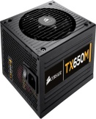 | Corsair Enthusiast Series Modular TX650M | - 650 W Power Output  - ATX 12V v2.31 and EPS 12V v2.92  - 1 x 12V Power Rail  - 100000 hours MTBF  8 SATA Cables | Rs. 9000 | 19 | Rs. 7250
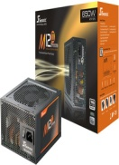 | Seasonic M12II-650 650 Watts PSU | - 650 W Power Output  ATX 12V v2.3  1 x 12V Power Rails  8 SATA Cables  Fan 1 | Rs. 8500 | 16 | Rs. 7100
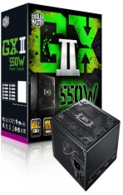 | Cooler Master GXII 550W | - 550 W Power Output  ATX 12V v2.3  1 x 12V Power Rails  - Fan 1  6 SATA Cables | Rs. 7899 | 22 | Rs. 6139
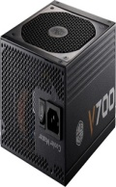 | Cooler Master Vanguard 700 Watts | - 700 W Power Output  - 9 SATA Cables  Fan 1  Fully Modular Cable Design  4 Peripheral Connector with 4 pins | Rs. 19700 | 35 | Rs. 12685
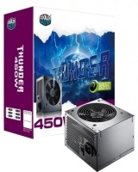 | Cooler Master Thunder 450W | - 450 W Power Output  - ATX 12V V2.3  - 2 x 12V Power Rail  6 SATA Cables  3 Peripheral Connector with 4 pins | Rs. 2656 | 0 | Rs. 2656
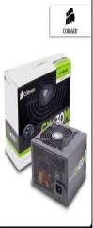 | Corsair CX430M 430 Watts | - 430 W Power Output  - ATX12V 2.3  - 2 x 12V Power Rail  2 SATA Cables  85% energy efficiency | Rs. 5000 | 22 | Rs. 3875
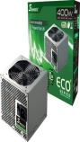 | Seasonic SS400BT PSU | - 400 W Power Output  - ATX 12V V2.3  4 SATA Cables  2 Peripheral Connector with 4 pins  All-in-one DC Cabling Design | Rs. 3900 | 29 | Rs. 2750
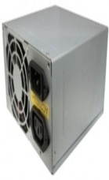 | Zebronic Zeb 450W | 450 W Power Output  - ATX 12V V2.3  2 SATA Cables  2 Peripheral Connector with 4 pins  AC 230V 50Hz 3.5A input | Rs. 799 | 28 | Rs. 568
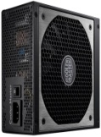 | Cooler Master Vanguard 1000 Watts | - 1000 W Power Output  9 SATA Cables  4 Peripheral Connector with 4 pins  Fan 1  Fully Modular Cable Design | Rs. 25000 | 35 | Rs. 16240
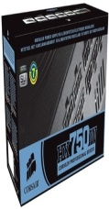 | Corsair CMPSU-750HXUK | - 750 W Power Output  ATX 12V v2.3  - 1 x 12V Power Rail  12 SATA Cables  8 Peripheral Connector with 4 pins | Rs. 12110 | 12 | Rs. 10599
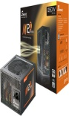 | Seasonic M12II 850 Watts | - 850 W Power Output  - ATX 12V v2.3  - 1 x 12V Power Rails  - 8 SATA Cables  - MODULAR POWER SUPPLY | Rs. 11000 | 20 | Rs. 8800
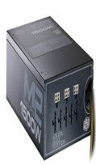 | Cooler Master Silent Pro M2 1500W | - 1500 W Power Output  - ATX 12V v2.3  - 1 x 12V Power Rails  12 SATA Cables  8 Peripheral Connector with 4 pins | Rs. 29999 | 13 | Rs. 25870

